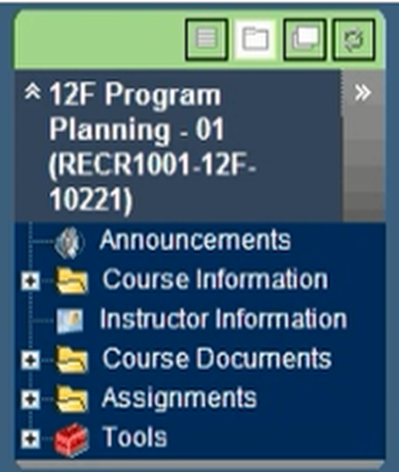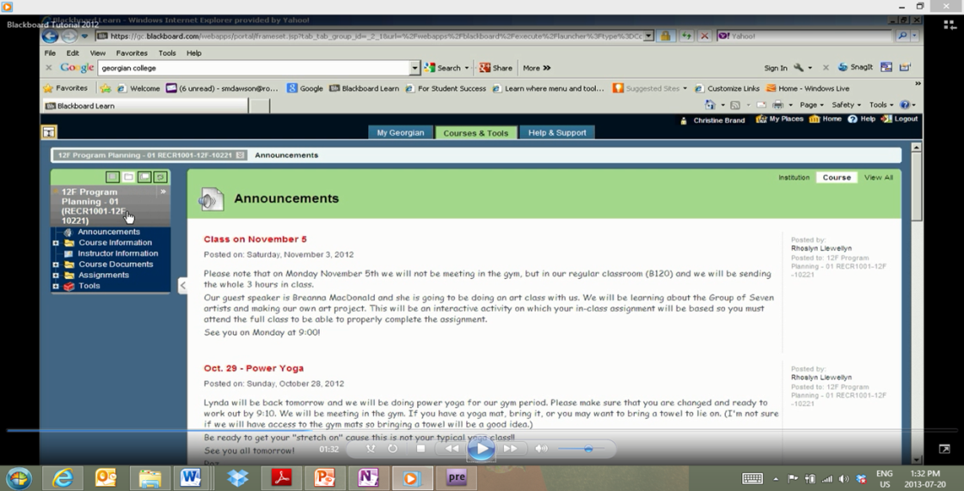jjj

**Student Number: __ __ __ __ __ __ __ __ __**

**Password Hint: ______________________**

**Course Menu**

**Announcements:** important course info may be posted here by the Instructor.   
**Course Information:** documentation for the course, including the official college Course Outline and Course Syllabus.  
 **Instructor Information:** instructor contact information including email and phone number. **Course Documents:** additional information such as PowerPoint presentations, lessons, course notes, videos, articles, websites, and question and answer sheets.   
**Assignments:** may provide access to assignment content provided by your instructor, such as assignments/marking scheme, deadlines, marking criteria, tests.  
**Tools:** your grades for each assignment.

* *Do you struggle with effective TIME MANAGEMENT and ORGANIZATION ?*
* *Have you been known to LOSE important papers ?*
* *Would you like to have ONE LOCATION where you can access*

*important notes, documents and messages 24/7 ?*

*If you answered ‘YES’ to any of these questions,*

*Sign-up and check in regularly with BLACKBOARD!*

**What is it?**

The Blackboard Learning

System is a web-based learning environment that helps you manage your dual credit course by providing a 24/7, one-stop **COURSE CONTENT** and **COMMUNICATION** resource for support inside and outside the classroom.

|  |  |
| --- | --- |
| **GETTING STARTED: 4 EASY STEPS !** | |
|  | Type *‘https://gc.blackboard.com/webapps/login/Google’* or google *Georgian College, Blackboard* to get started. |
|  | Look for the logo and click. Add the login page to your Internet Favourites. |
|  | Login using your 9-digit Georgian College *student number* and your *YYMMDD* password. (i.e. April 28, 1995 = *950428*) |
|  | Click on the *Courses and Tools* tab. Look for *Announcements, Course Information, Course Documents, Assignments* and ­(for My Grades). |

***Central Lakes Regional Planning Team***

***A School College Work Initiative***

***www.centrallakes.ca***

*Having difficulty logging in or finding what you are looking for?*

*Call college Tech Support @ 705.728.1968 ext.1732 or* [*itsupport@georgianc.on.ca*](mailto:itsupport@georgianc.on.ca)